Technical assessment - Rocket.Chat Enterprise Solutions team - Technical Support Analyst position - Marina Santos

link to my Rocket.Chat setup: https://75e20c246d05.ngrok.io

user: marvandort

password: Atena123

**Install and setup my Rocket.Chat**

For the installation and configuration of the server I used Virtual Box machine running Ubuntu 20.04.1

I used the documentation available at the link <https://docs.rocket.chat/installation/snaps> to configure and install the server, using the aid of Snaps. The process was quick and practical.

After completing a server configuration I pointed my localhost to port 3000 and entered the Rocket page to finish registering my account. I registered the login and followed all the necessary steps to finish creating the account

As it was pointing only at my machine I used Ngrok to create a connection, so you can have access to the server too. Ngrok maps the localhost, pointing to the set port and allowing access via an external network.

I performed tests on my machine, they worked normally.

Below are all screenshots showing all the steps mentioned above.

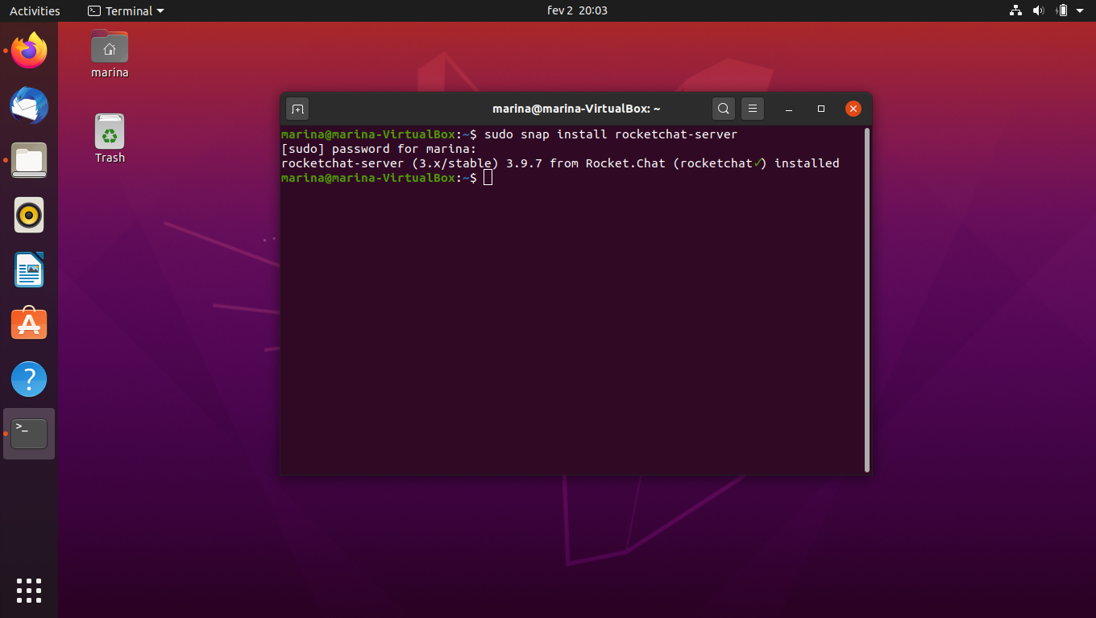

Terminal Rocket.Chat Server installation using snaps

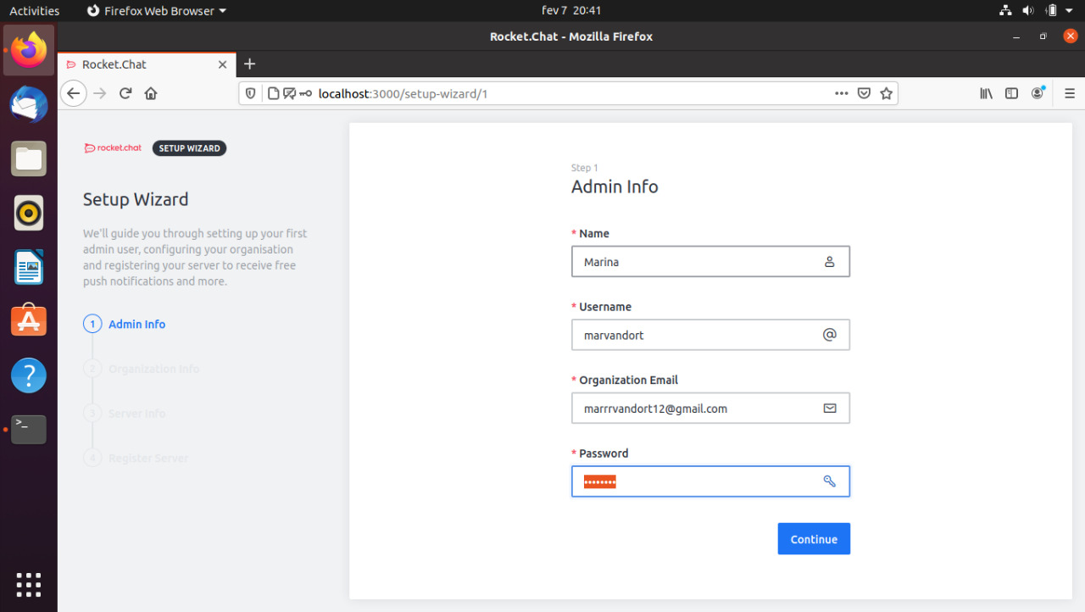

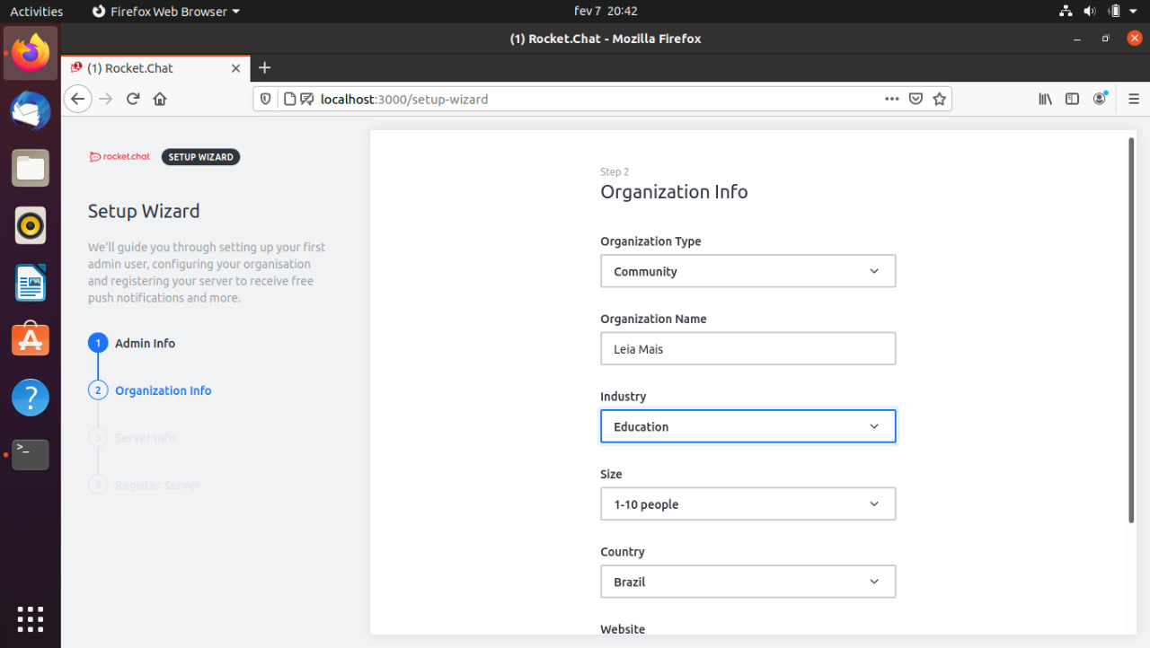

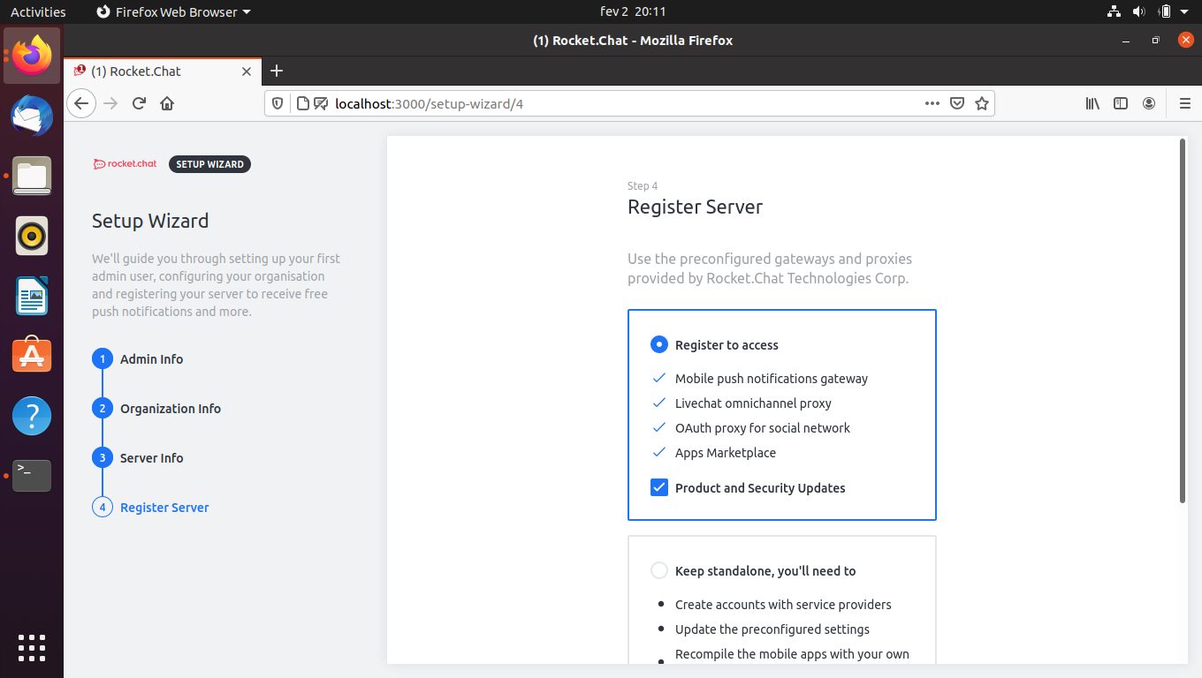

Account Created

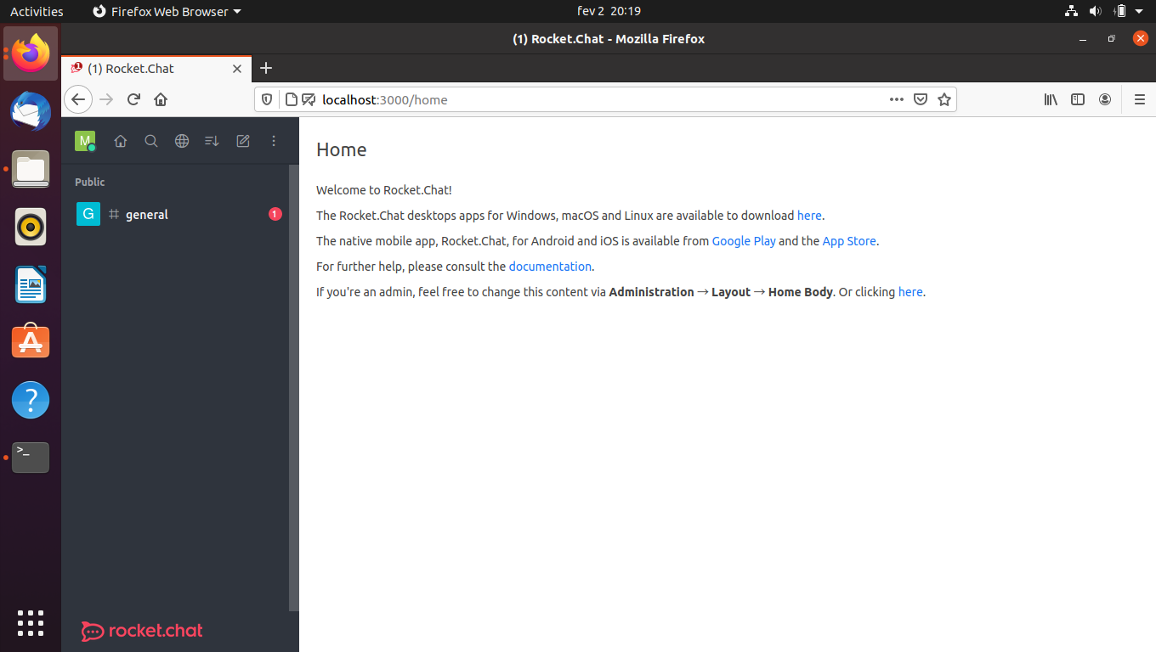rocket.chat server home page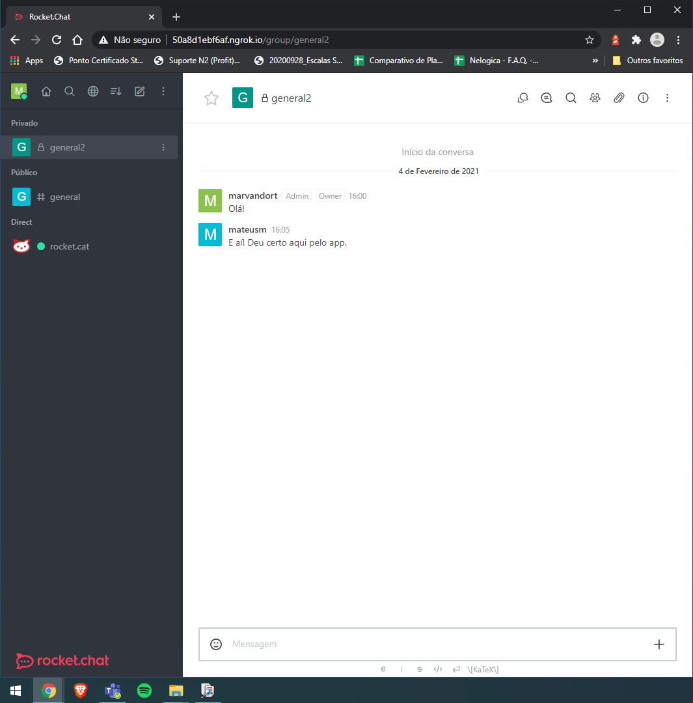   
testing server access via external network

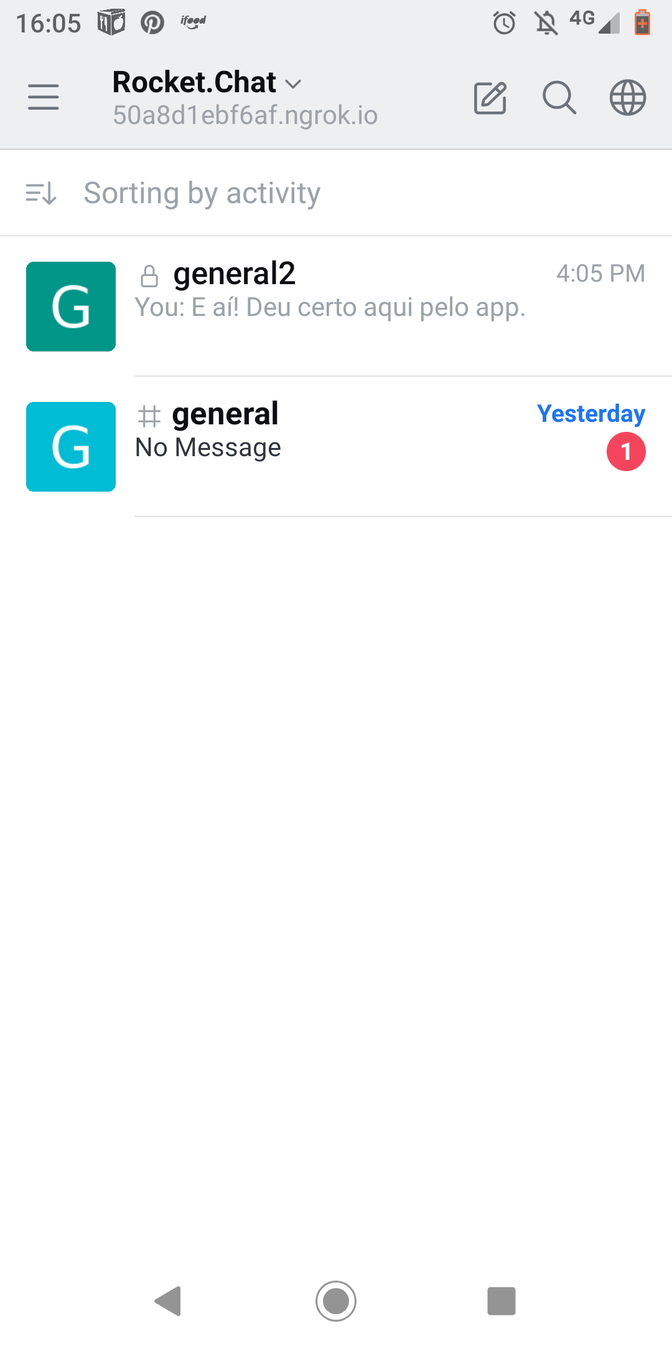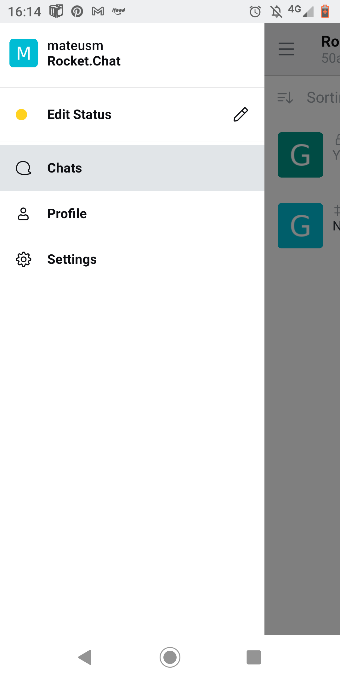

testing access via mobile app with the server link. I used the user data created in the API

**API’s**

I did all the chores using the Ubutu Terminal, all the tests were OK and return what it was asked. I’d try to used the Postman at first, but it presented some errors and I ended up opting for the terminal.

I used the content available in the docs, at the link https://docs.rocket.chat/api/rest-api/methods/authentication/login I got everything I needed to know to login via API

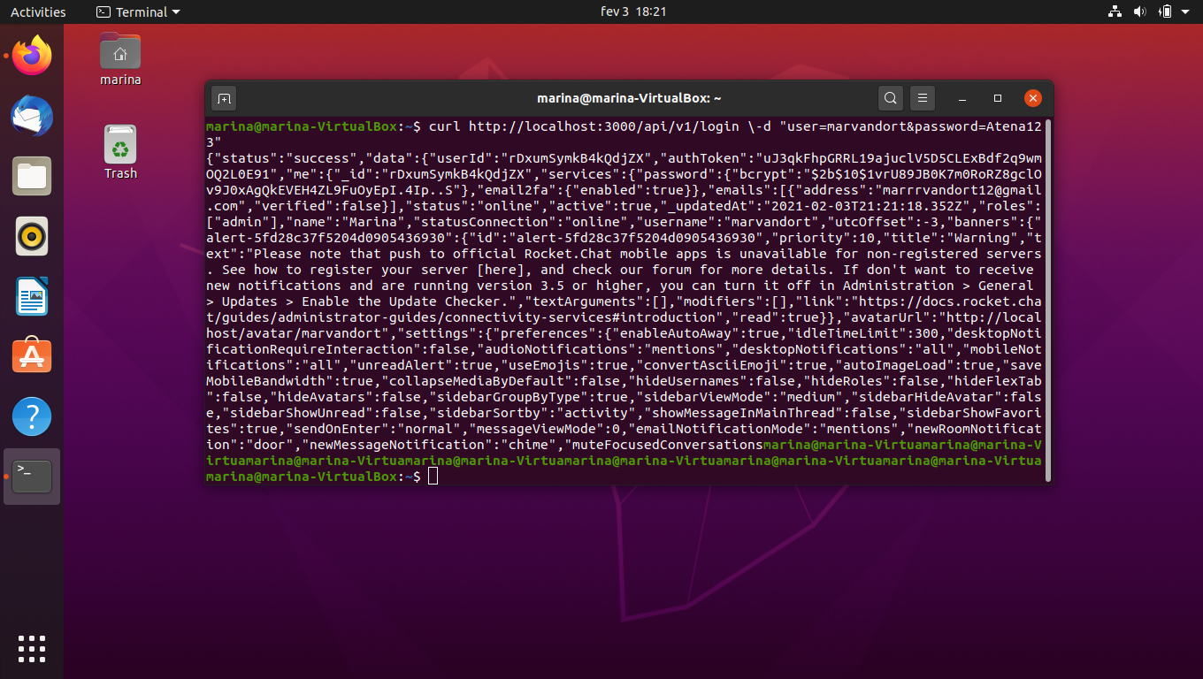

Server login

**Task 1 - User creation**

With the commands available in the API's docs I created the user "mateusm", first directing my Authtoken and userID. I used the content available at https://docs.rocket.chat/api/rest-api/methods/users/create

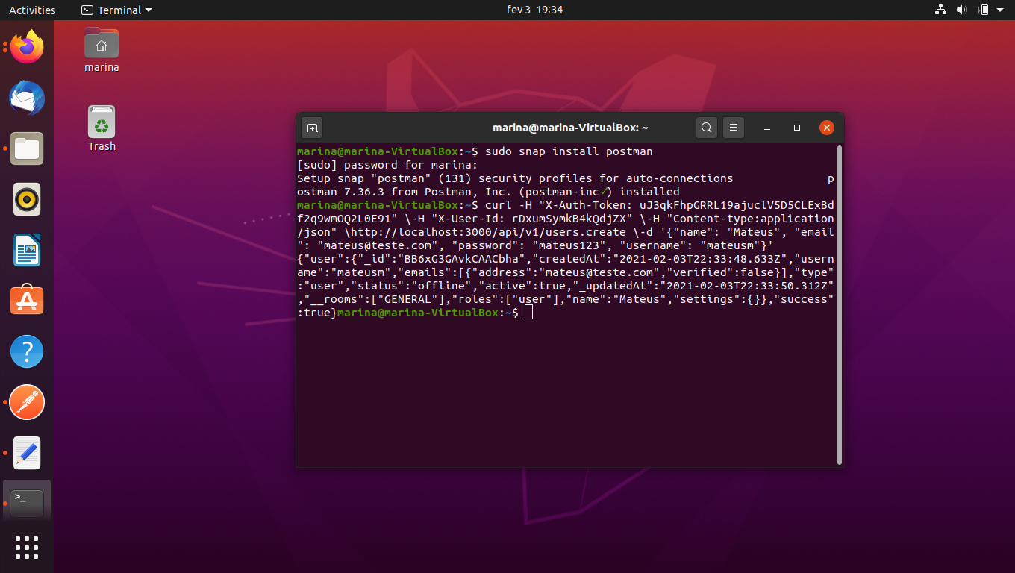Terminal users.create and response.

**Task 2 - Get the Room information**

The same server and ID parameters were kept, and I used the command rooms.get that is also available in the docs. Também não tive dificuldade nessa API, todo o conteúdo dos docs me ajudou muito. O link que usei para resolver essa tarefa foi https://docs.rocket.chat/api/rest-api/methods/rooms/get.

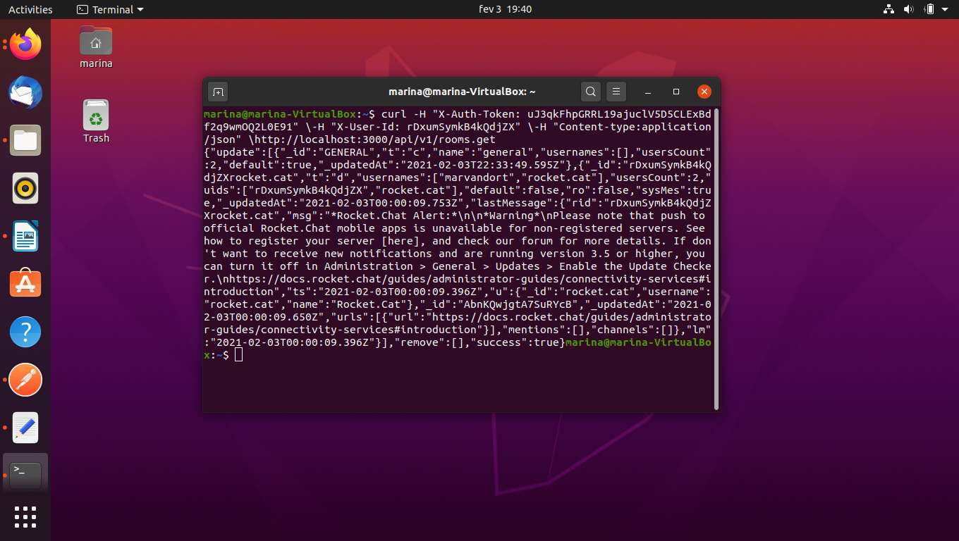

Terminal rooms.get and response

**Task 3 - Get a list of all user roles in the system**

For this task only the parameters ID and Authtoken are required. The command to request the list on localhost was roles.list.

There was no difficulty in this last task either, just follow the steps available at the link https://docs.rocket.chat/api/rest-api/methods/roles/list

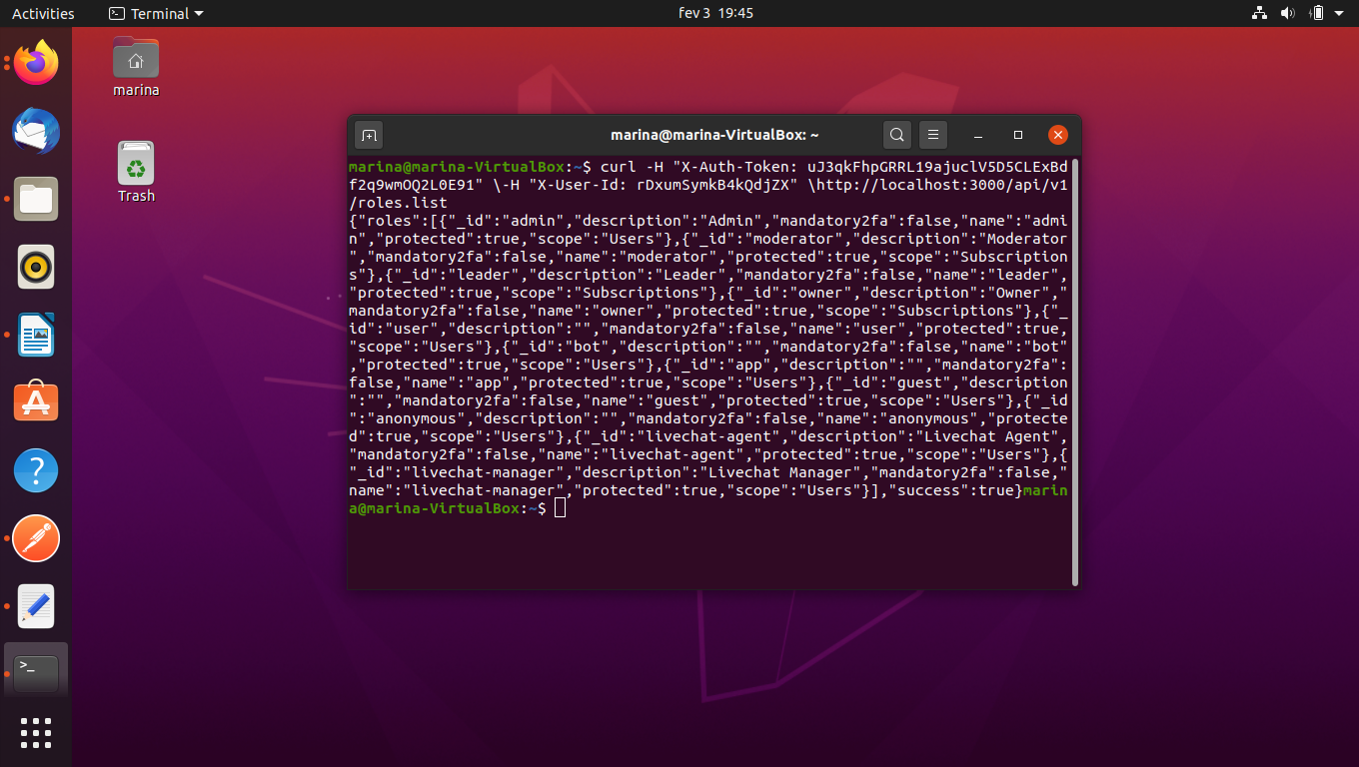

Terminal roles.list and response